Sources code my website

<https://github.com/cuongnmhe140724/VietTrip-Site>

W3 validator compliant

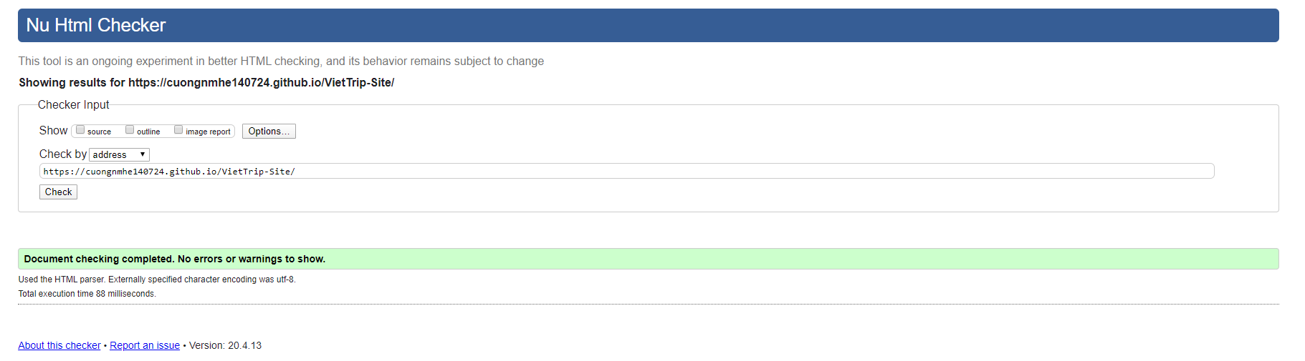

Responsive check

